What is my feeling?  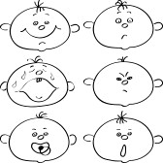 | What is my zone? | Tool I used | What is my zone? | Help?
 |  |  |  | Y | N

What is my feeling? | What is my zone? | Tool I used | What is my zone? | Help?
 |  |  |  | Y | N

What is my feeling? | What is my zone? | Tool I used | What is my zone? | Help?
 |  |  |  | Y | N

What is my feeling? | What is my zone? | Tool I used | What is my zone? | Help?
 |  |  |  | Y | N

